Yelena Muradyan
24 Aug 2024

Executive Summary

The purpose of this PRD is to define the requirements for Step 2 of the user onboarding journey for our source management platform. This step involves offering users the option to import their existing bookmarks from their browser. By implementing this feature, we aim to solve the zero start problem, enabling users to begin their experience with the platform with the exciting knowledge base they have collected in the past.
Feature Name | Bookmarks Import
Product Area | Onboarding Flow/ STEP 2
User Persona/ Story | All Haibrid new users.  As a user, I want a smooth zero start, when just starting out with a new platform, aka Haibrid.
Description | Overview  Haibrid is designed to help users collect, organize, manage, and access various sources efficiently. The onboarding process is divided into three steps:  Step 1. Personal Info  Step 2. Import Bookmarks  Step 3. Extension SetUp,  where Step 2 will help users get started quickly, by automatically importing existing bookmarks from their browser. With the user's permission, this step ensures that they don’t encounter an empty platform upon signing up. By transferring their already curated sources into Haibrid, users carry over the value they've already created, allowing them to continue their work in a better-organized space.  Key Features  - Bookmark import from user’s default browser  - Reading list import from user’s default browser  - Organization of bookmarks on user’s dashboard
User Problem | New users often face a "zero start" issue, where they begin using a platform with no existing data or content. This can be a barrier to engagement as it may be challenging to populate the platform with meaningful content from scratch. Step 2 onboarding resolves this by allowing users to import their existing bookmarks, ensuring they can immediately carry over the value they've already created. This seamless transition means users won't have to go back and forth to find their previously collected links, dividing their attention, making the onboarding process smoother and more engaging. As a result this will enhance user retention and increase platform stickiness.
Value Proposition | - Instant Usability  By importing bookmarks, users can immediately start using Haibrid with content they are already familiar with, enhancing their initial interaction with the platform.  - Time-Saving  Users save valuable time by avoiding the manual input or search for their preferred resources, leading to a more engaging and satisfying onboarding experience.  - Preserving Value  Users won't have to worry about losing the value of their previously organized and collected bookmarks and reading lists. This reassurance makes the decision to start using Haibrid easier as they can seamlessly integrate their past efforts into the new platform.  - Focused Attention  By having all their previously collected links in one place within HB, users can maintain their focus and avoid the distraction of going back and forth between different platforms to find their resources collected in the past.
Objectives | Increased User Engagement  Ensure users interact with the platform immediately after sign-up by providing them with ready-to-use content.  Reduce Drop-off Rates  Minimize the number of users who abandon the platform during the onboarding process due to a lack of initial content.
Assumptions | - Some users might be on a different platform than Chromium  - Some users might not be sure if they trust the platform and if importing the bookmarks is even worth the effort. Might keep the option after adopting the platform  - Users might need a clarification that their reading list will be imported as well
KPIs | To evaluate success of this feature the following metrics should be tracked:  - Import_done (import completion rate)  Track the percentage of users who successfully import bookmarks during the onboarding process. This metric will help assess how effectively the feature is being utilized and whether users encounter any issues during the import process.  - User retention rate  Compare retention rates between users who imported bookmarks and those who did not. This will provide insights into whether the bookmark import feature contributes to higher user engagement and long-term platform use.  - Onboarding_done (onboarding completion rate)  Measure the percentage of users who complete the entire onboarding process after importing bookmarks. This will help determine if the bookmark import feature encourages users to complete their onboarding journey, setting them up for success on the platform.
MVP | - Import Functionality  - Skip Importing  - Error Handling  - Bookmark Sorting
Requirements | - Import Functionality  Users will be able to import bookmarks and reading lists from Chrome and Chromium browsers (aka Arc, Opera, Brave, Edge, etc).  - Skip Importing  Users will be able to skip this step at the beginning of their journey, however they should have an option of importing bookmarks from their profile settings.  - Error Handling  Basic error messages will be displayed if the import fails, guiding users on how to resolve issues.  - Let’s think of something fun for a “something went wrong” error message.  - In case of a not- Chromium Browser error, let’s again put an entertaining message  - Bookmark Sorting  Imported bookmarks and reading list will be sorted out with the following logic:  - Folders: all links that come from a bookmark folder will be imported as a projects, inheriting Folder name as a project name  - Reading list will be imported as a separate folder titled “Reading List”  - All sources that are not grouped under a folder, will be imported to unassigned.
Open Questions | Can we have the functionality to merge bookmarks from various browsers? (e.g. someone uses Chrome and Arc equally frequently)

Appendix: Can add import from other bookmarking apps functionality at later stage:
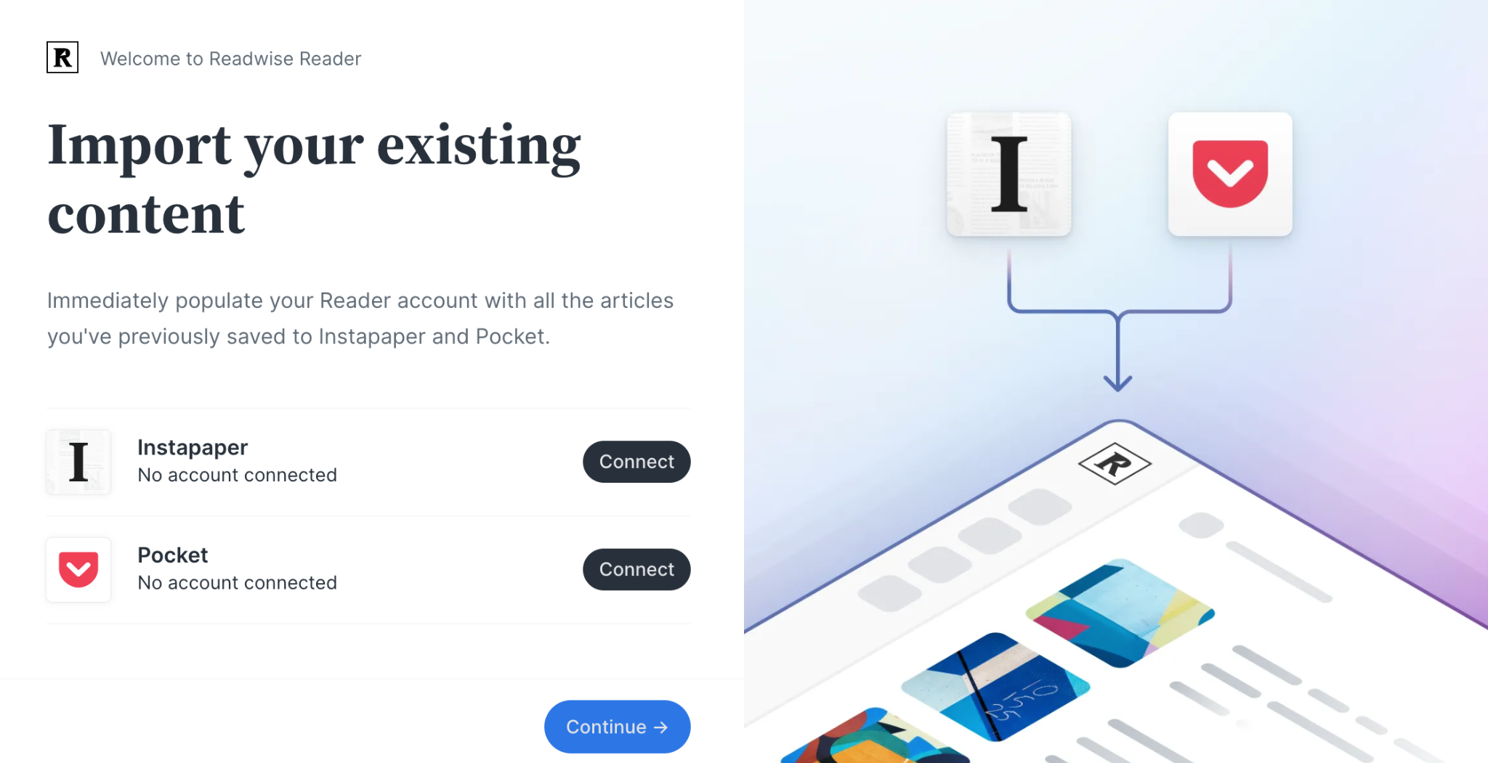
Readwise reader example

